ASSESSMENT + SATISFACTION SURVEY PRIMARY SCHOOL
E-CLIL 2.0 PROJECT 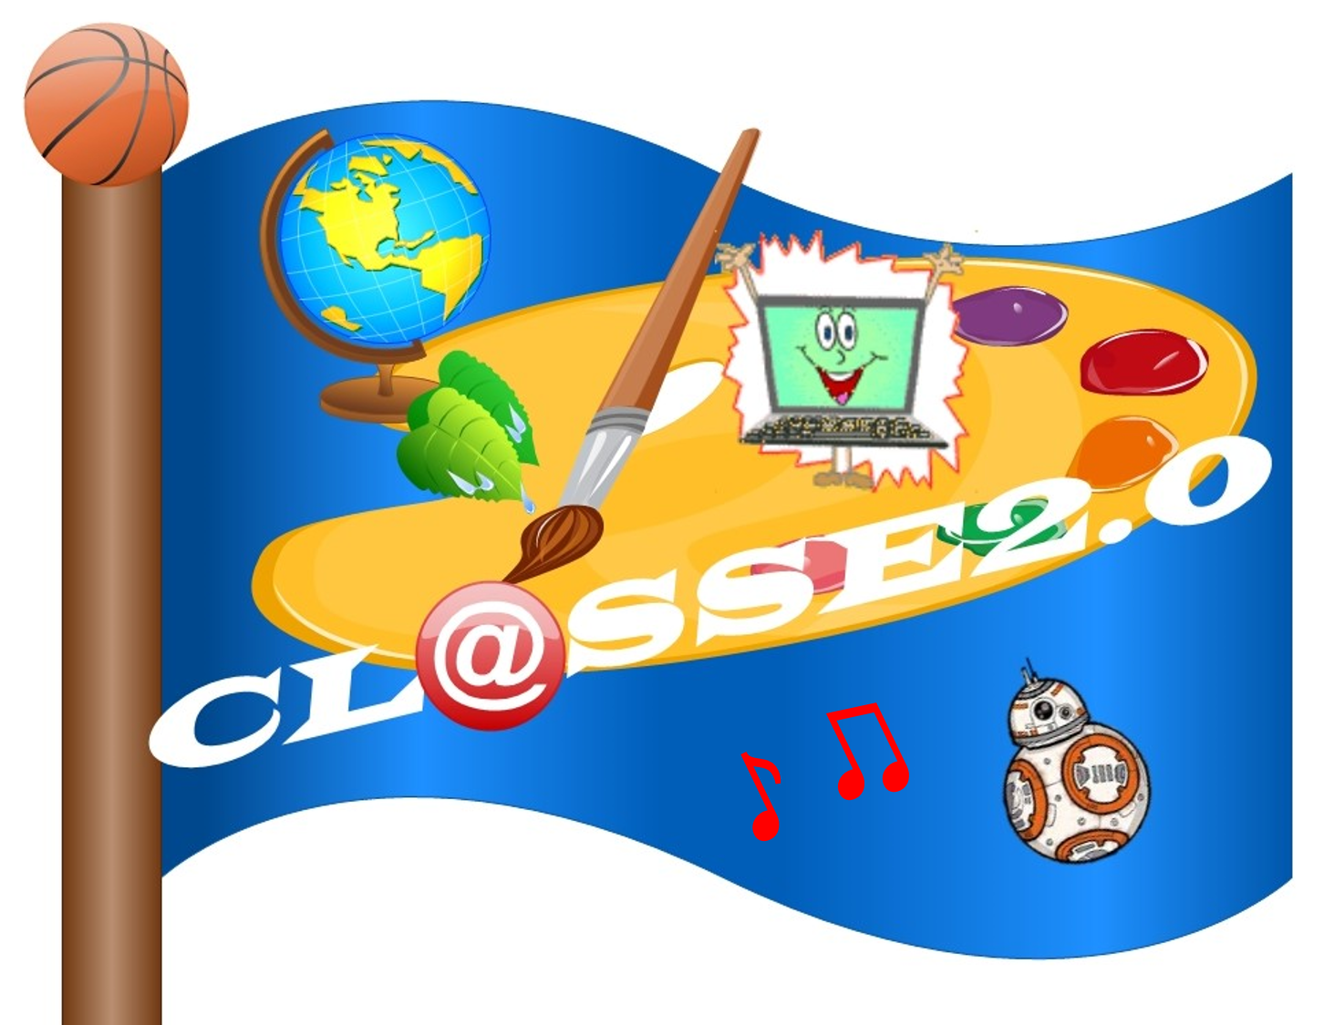
Class ………..

Do you like e-CLIL 2.0 project lessons?
Very much Enough Little

MOTIVATION
- The lessons are …
Difficult
Easy
- The e-CLIL experience is ……

Interesting

Useful

Boring

ORGANISATION – INTERACTION
- The quality of education material used for the project is ...

Good

So and so

Bad

- The group work is .....

Exciting

Easier than traditional work

Waste of time

LEARNING MONITORING
- The e-CLIL project helps you to ....

Speak

Write

Use new technology

- The subjects in your project are:

......................................................................................................

- Material used in class helps you to ......

Understand the project

Learn new things

Learn English

Do nothing

- Would you recommend this school project to other classes?

Yes No

- Give a mark to the project !

Very bad Bad Sufficient

Good Very good Excellent

